**United States Department of Agriculture**

Food and Nutrition Service

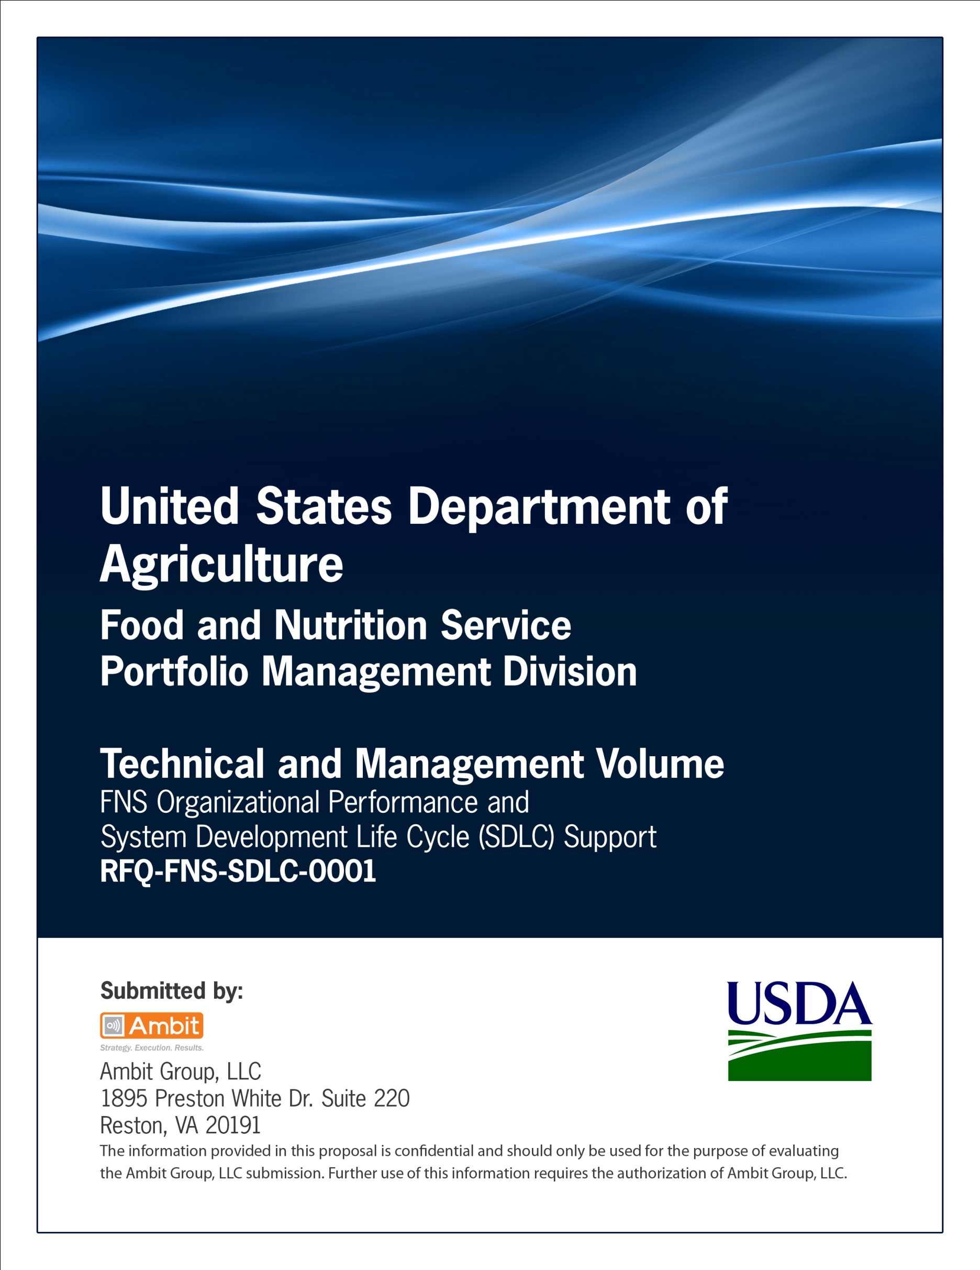

**FNS Office of Information Technology**

**Portfolio Management Division (PMD)**

**FNS System Requirements Specification Template**

**(SRS)**

**for**

**[Project or System Name]**

**Version 1.1**

September 09, 2013

**Revision History**

|  |  |  |  |
| --- | --- | --- | --- |
| **Version** | **Date** | **Author** | **Change Description** |
| 1.0 | 03-12-2013 | IT Governance Branch (ITGB) | Created the document |
| 1.1 | 09-09-2013 | IT Governance Branch (ITGB) | Re-formatted the document. |
| 1.2 |  |  |  |
| 1.3 |  |  |  |

**Contact Information**

|  |  |
| --- | --- |
| **Area of Concern** | **Contact Person** |
| IT Governance Lead | Kevin Russ |
| SDLC Coordinator | Syed Jaffery |
| ITIRB Coordinator | Sunny Dilawari |
| Portfolio Management Division Director, Chief Portfolio Officer | Jacqueline Butler |
| Program Management Branch Chief | Allison Willcox |

Contents

Glossary 5

1. Introduction 6

1.1. Document Description 6

1.2. Scope of System Requirements Specification 6

1.3. Points of Contact 6

1.4. Organizational Background 7

1.5. Organizational Structure 7

1.6. RACI Chart 7

2. Project Description 8

2.1. Background/Recent History 8

2.2. Purpose 8

2.3. Objectives 8

2.4. Current Functionalities 9

2.5. Application languages 9

2.6. Number of users 9

2.7. Problem Statement 9

2.8. Data Input 10

2.9. Data Output 10

2.10. Deficiencies 10

3. “As Is” System Activity Diagrams 10

4. Requirements 10

4.1. Requirement Statement 10

4.2. Requirement Cross-Identification 11

5. “As Is” SYSTEM Requirements 11

6. “To-Be” SYSTEM Functionality 11

6.1. Assumptions and Constraints 11

6.2. Timeliness 12

6.3. Summary of Impacts 12

7. “To-Be” Activity Diagrams 13

8. “To-Be” System Requirements 13

9. User Classes and Modes of Operation 14

9.1. *Classes/Categories of Users* 14

9.2. *User Classes Mapped to Functional Features* 14

9.3. Operational Scenarios 14

10. Use-Case Specification 14

10.1. Use Case Description 14

10.2. Preconditions 14

10.3. Action 15

10.4. Alternative Flows 15

10.5. Outputs 16

10.6. Exceptions 16

Appendix A: References 17

Approvals/Signatures 18

# Glossary

| **Acronym** | **Description** |
| --- | --- |
|  |  |
|  |  |
|  |  |
|  |  |
|  |  |
|  |  |
|  |  |
|  |  |

# Introduction

## Document Description

The System Requirements Specification (SRS) is a formal statement of the application functional and operational requirements. It serves as a contract between the developer and the customer for whom the system is being developed. The developers agree to provide the capabilities specified. The client agrees to find the product satisfactory if it provides the capabilities specified in the SRS.

## Scope of System Requirements Specification

Discuss the scope of the document and how it accomplishes its purpose.

The scope of the SRS is to act as the central document for the development of the System Name system. It shall be used throughout the system development process for the following:

1. Designing and developing the application system.
2. Evaluating the product in all subsequent phases of the life cycle.
3. Determining the success of the project.

The SRS has the following characteristics:

1. It is verifiable. All the functional requirements have been prepared keeping the subsequent (design, implementation and testing) development phases in mind. At any stage, the document shall prove as a reference to verify information.
2. It contains a complete set of requirements for the application.
3. The SRS is a statement of what the application is to do-not of how it works. The SRS does not commit the developers to a design. For that reason, any reference to the use of a specific technology is not appropriate in an SRS, unless specifically highlighted as a requirement by the customer.

It is traceable. All the requirements in the SRS can be traced back from a later stage during the development process.

## Points of Contact

List the names, titles, and roles of the major participants in the project.

|  |  |  |  |  |
| --- | --- | --- | --- | --- |
| **Name** | **Title** | **Contact Phone Number** |  | **Contact Email** |
|  | Project Sponsor |  |  |  |
|  | OIT Project Manager |  |  |  |
|  | SME |  |  |  |
|  | Business Analyst |  |  |  |
|  | Architect |  |  |  |
|  | Developer |  |  |  |
|  | Tester |  |  |  |
|  | End User |  |  |  |

## Organizational Background

Describe the organization and its overall responsibilities.

## Organizational Structure

Describe the organizational structure of the project team, including management and other review authorities.

## RACI Chart

This section displays the RACI Chart for the project.

| **Phases** | **Templates** |  | **Roles** | | | | | | | | |
| --- | --- | --- | --- | --- | --- | --- | --- | --- | --- | --- | --- |
|  | R-Responsible  A-Accountable  C-Consult  I-Informed | **Project Sponsors** | | **SME’s** | **OIT PM** | **Business Analyst** | **IT Architect** | **Network Managers** | **Developers** | **Testers** | **End Users** |
| Initiation | **Business Case** | R | | CI | A | I | I | I | I | I | I |
| **Project Plan** | A | | C | R | I | I | I | I | I | I |
| Requirements Gathering & Analysis | **PTA, PIA, SORN, Electronic Information System Questionnaire for Records Management Scheduling** | C | | C | R/A | I | I | I | I | I | I |
| **System Requirements Specification** | C | | C | A | R | I | I | I | I | I |
| Design | **Procurement Documents** | A | | C | R | I | I | I | I | I | I |
| **System Design Document** | I | | I | A | C | R | C | C | I | C |
| Development | **Test Plan** | I | | I | A | C | C | I | I | R | I |
| Integration | **Transition Plan** | I | | I | A | C | R | I | C | I | I |
| Testing | **Test Results** | I | | I | A | C | C | I | C | R | I |
| Implementation | **Installation Document** | I | | I | A | C | R | C | R | I | I |
| **Application Guide** | R | | R | A | R | C | C | C | I | I |
| Operations/  Maintenance | **Standard Operating Procedures** | I | | I | A | I | I | R | R | R | I |
| Disposition | **System Disposition Plan** | R | | I | R/A | I | I | I | I | I | C |
| **Post Termination Review Report** | C | | I | R/A | I | I | I | I | I | C |

# Project Description

## Background/Recent History

If this is the first attempt to acquire the item or service, indicate “Not applicable.” Otherwise, briefly describe background information concerning the uses and purposes of the “As-Is” system.

## Purpose

In this section, provide the purpose this application is intended to serve.

## Objectives

List the functional Capabilities that will be provided in a solution. Describe in terms of problems that will be solved, issues to be addressed or functions to be performed.

1. Capability Shortfall, Problem or issues to be addressed
   * 1. Improvement#1
     2. Improvement #2
     3. Improvement #3

For example:

* Provide optimal reach to audiences
* Better serve specific audiences
* Broaden user base

1. Functions

List functions to be performed.

* + 1. Function #1
    2. Function #2
    3. Function #3

For example:

* Provide updated and expanded data
* Enhance functionalities and capabilities
* Employ up-to-date technology

## Current Functionalities

Provide the major performance requirements and current functionalities of the “As-Is” system.

## Application languages

Select the language used to develop the “As-Is” system.

For example:

1. Java
2. .Net
3. C++

## Number of users

Specify number of users using the current system.

1. 0-10
2. 11-25
3. 26-50
4. 51-100
5. 101-200
6. 200+
7. Other(Please Specify)

## Problem Statement

Summarize condition that created need for new system.

For example:

1. Problems with existing system
2. Desire to exploit new opportunities
3. Desire to make more effective use of information
4. Organizational growth
5. Merger or acquisition
6. Change in market or external environment
7. New laws or regulations

## Data Input

Is the input keyed into the system, scanned, or migrated? Where does the data originate (e.g. states, regulated community)?

## Data Output

Show the systems main products and the frequency of their preparation.

For example, reports, tables, charts, graphic displays, catalogs, or correspondence prepared weekly, monthly or yearly. Also indicate whether the information is transferred to other systems.

## Deficiencies

List any deficiencies in the current system.

1. Deficiency #1
2. Deficiency #2
3. Deficiency #3

For example:

1. Missing reporting feature.
2. Data cannot be exported to external systems.

# “As Is” System Activity Diagrams

Include activity diagrams of the “As Is” system.

# Requirements

## Requirement Statement

The requirements must be phrased with the definitive word “shall” and have a unique number for reference purposes. Each requirement and its identifier must be in a separated paragraph, i.e., one “shall” per paragraph.

For example:

4.5.2 Provide Project Planning Capability

4.5.2.0 The system shall provide a project planning capability

4.5.2.0.1 The system shall allow authorized users to enter project plans and timelines

4.5.2.0.2 The system shall allow authorized users to review, change, or update project plans and timelines

## Requirement Cross-Identification

The unique identification of requirements is an essential attribute of the requirement itself. Requirements that include lists can be handled in one of two ways. Each item in a list can have its own “shall” statement or be numbered (a), (b), (c), etc., or (i), (ii), (iii), etc. In this way, a requirement can be identified by its paragraph requirement number coupled with letter (a) or number (i).

Caution: Bullets or other repetitive symbols are not permissible because they would not be unique identifiers.

Note: The parentheses shown around the sublevel identifiers are shown for emphasis purposes only and are not part of the standard.

# “As Is” SYSTEM Requirements

| **Requirement ID** | **Requirement Description** | **Input values** | **Business Rules/Data attributes** | **Output values** | **Use Case Reference** |
| --- | --- | --- | --- | --- | --- |
| Insert a Unique Requirement ID. | State the requirement details. | List input values associated with the requirement. | List Business Rules associated with the requirement.  Business rules can include facts, constraints, action enablers, computations and interfaces. | List output values associated with the requirement. | Insert Use Case Number associated with the requirement. |
| For Example: |  |  |  |  |  |
| R-1.5 | The system shall allow user to enter username. | Username | Allowable username shall be 5-7 characters. | None | U-5.0 |

# “To-Be” SYSTEM Functionality

## Assumptions and Constraints

List user assumptions and constraints that will affect development and operation of the system.

**Assumptions**

State the assumptions associated with development of the system, where assumptions are defined as future situations, beyond the control of the project, whose outcomes influence the success of a project.

For example:

1. Availability of a hardware/software platform
2. Pending legislation
3. Court decisions that have not been rendered
4. Future trends in immigration and naturalization
5. Developments in technology

**Constraints**

State the constraints associated with the development of the system, where constraints are defined as conditions outside the control of the project that limit the design alternatives.

The following are examples of constraints:

1. Government regulations
2. Technical standards imposed on the solution

For example, the use of a specific Database Management System

1. Strategic decisions
2. Constraints exist because of real business conditions.

For example, a delivery date is a constraint only if there are real business consequences that will happen as a result of not meeting the date. If failing to have the subject application operational by the specified date places the FNS in legal default, the date is a constraint.

## Timeliness

Provide server response time requirements compared to current system.

## Summary of Impacts

Summarize the anticipated impacts and associated costs of the proposed system on the existing organizational and operational environments.

**User Organizational Impacts**

Organizational impacts may include the modification of responsibilities and the addition or elimination of responsibilities that will be necessary to use the proposed system.

Provide Organizational impacts.

1. Organizational impact #1
2. Organizational impact #2
3. Organizational impact #3

**User Developmental Impacts**

Provide user developmental impacts.

1. Developmental impact #1
2. Developmental impact #2
3. Developmental impact #3

For example: All milestones and baselines will be used by the customer to review progress and ensure proposed system objectives are being met.

# “To-Be” Activity Diagrams

Include activity diagrams of the “To Be” system. For example:



# “To-Be” System Requirements

List the requirements of the system.

|  |  |  |  |  |  |
| --- | --- | --- | --- | --- | --- |
| **Requirement ID** | **Requirement Description** | **Input values** | **Business Rules/Data attributes** | **Output values** | **Use Case Reference** |
| Insert a Unique Requirement ID. | State the requirement details. | List input values associated with the requirement. | List Business Rules associated with the requirement.  Business rules can include facts, constraints, action enablers, computations and interfaces. | List output values associated with the requirement. | Insert Use Case Number associated with the requirement. |
| For Example: |  |  |  |  |  |
| R-2.8 | The system shall allow user to click on “More information” link. | None | None | None | U-7.0 |

# User Classes and Modes of Operation

## Classes/Categories of Users

Identify and describe the major classes/categories of users that will interact with the system (or capability).

1. Administrator
2. User
3. Other(Please specify)

## User Classes Mapped to Functional Features

In this section provide an explanation of what functions each user organization can access or use. Define any variations in the user work process that correspond to the use of the system by the different classes of users.

## Operational Scenarios

Develop sample usage scenarios for each major user class.

|  |  |
| --- | --- |
| **USER** | **SYSTEM FUNCTIONS** |
| Specify User type | Specify actions allowed by the user. |
|  |  |
|  |  |
| For example:  Administrator | For example:  The system shall allow administrator to add, edit and delete data. |

# Use-Case Specification

## Use Case Description

Describe main business goals of the use case.

For example: This use case enables the user to enter their name, age, weight, and other required information to generate a Plan for the user.

## Preconditions

Specify the conditions that must hold true before the scenario of the use case starts and will not be checked again.

For example: User accesses Home Page.

## Action

List the sequence of interactions necessary to successfully meet the goal. The interactions between the system and actors are structured into one or more steps which are expressed in natural language. A step completes when all its component interactions have completed.

1. Step #1
2. Step #2
3. Step #3

For example:

1. The user enters age, sex, height, weight as specified in Data Elements.
2. The user submits the information to the system.
3. System validates the required data elements as specified in Data Elements.
4. The system displays Plan for user.

## Alternative Flows

List any secondary paths or alternative scenarios to the basic flow.

**Alternative 1**

1. Step #1
2. Step #2
3. Step #3

**Alternative 2**

1. Step #1
2. Step #2
3. Step #3

For example:

1. If the user did not enter a required field
2. The system validates the required information if there is required field that is missing the system displays a message indicating :
   1. “You must enter your age”,
   2. “Age must be 2 or older”,
   3. “You must select your sex”,
   4. “You must select your physical activity.”
3. Return to Step 1 in the Basic Flow
4. User’s Age is more than 110
5. If the user’s age is more than 110, message stating “Age must be 110 or younger” is displayed
6. Return to Step 1 in the Basic Flow

**Data Fields**

List data elements used in the use case.

| **Data Element Name** | **Description** | **Type** | **Length** | **Data Format or Values** | **Business Rules** | **Label** |
| --- | --- | --- | --- | --- | --- | --- |
| Enter name of the data field. | Describe the data field. | Enter type of data field. | Specify length of the data field. | Specify allowable format for the data field. | Specify business rule/s for the data field. | Specify label of the data field. |
| For example: |  |  |  |  |  |  |
| Age | The age of person. | Number | 1-3 characters |  | Age must be 110 or younger | Age |
| Sex | The sex of the person. | Single Selection | Not applicable | Male, Female | Required | Sex |
| Weight | The Weight of the person. | Number | 1-3 characters | Pounds | Optional | Weight |
| Height | The height of the person. | Number | 1’-7’ 9” | Feet and inches | Optional | Height |

## Outputs

Describe the change in state of the system after the use case completes.

For example: System displays the Plan based on user profile information supplied.

## Exceptions

Provide list of exceptions.

1. Exception #1
2. Exception #2
3. Exception #3

Provide a list of attachments to be delivered along with this document.

1. Attachment #1
2. Attachment #2
3. Attachment #3

# Appendix A: References

Insert the name, version number, description, and physical location of any documents referenced in this document. Add rows to the table as necessary.

The following table summarizes the documents referenced in this document.

|  |  |  |
| --- | --- | --- |
| **Document Name** | **Description** | **Location** |
| Document Name and Version Number | Document description | URL or Network path where document is located |
|  |  |  |
|  |  |  |

# Approvals/Signatures

The undersigned acknowledge that they have reviewed the [name of document] document and agree with the information presented within this document. Changes to this document will be coordinated with, and approved by, the undersigned, or their designated representatives.

|  |  |  |  |
| --- | --- | --- | --- |
| Signature: |  | Date: |  |
| Print Name: |  |  |  |
| Title: |  |  |  |
| Role: | [Project or System Name] Project Manager |  |  |
|  |  |  |  |
| Signature: |  | Date: |  |
| Print Name: |  |  |  |
| Title: |  |  |  |
| Role: | [Project or System Name] Business Owner |  |  |
|  |  |  |  |
| Signature: |  | Date: |  |
| Print Name: |  |  |  |
| Title: |  |  |  |
| Role: | Organization’s Approving Authority |  |  |